Our Ref: _______________ Your Ref: ________________________ Date: __________________

Baptist Church

Baale Yaku Site Area, P. O. Box 644,

Ogbomoso, Oyo State. Tel. 07052425407

Email: [newsprinbaptistchurch@gmail.com](mailto:newsprinbaptistchurch@gmail.com)

Website: newspringbc.comze.com

NEW SPRING

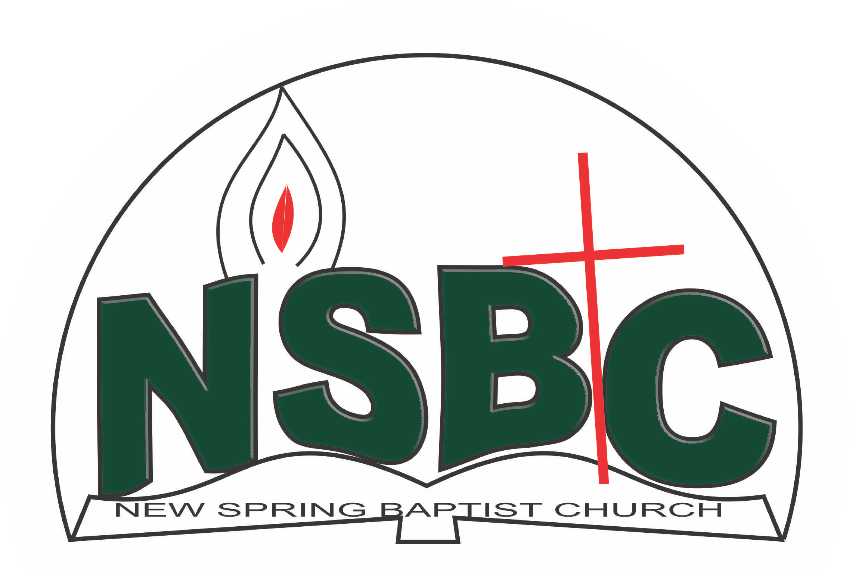

3 January 2022

Dear Dns. Mrs. Oluwayemisi Fatioloro,

Nomination to Serve as a Worker in the Church in 2022.

Calvary greetings in the precious name of our Lord and Saviour Jesus Christ. It is our pleasure to inform you that at the Church-in-Conference held on December 19, 2021; the Church ratified your nomination to serve in the following areas between January 1 and December 31, 2022:

1. Discipler, Discipleship Training Committee under the Leadership of Dn. Dr. OmoOlorun Olupona
2. Member, Intercessor Committee under the Chairmanship of Mrs. Funke Oyekunle
3. Member, Marriage Counseling Committee under the Chairmanship of Rev’d Kayode Oke
4. Diaconate member, Deaconess1
5. Member, Church Council under the Chairmanship of Revd. Kayode Oke
6. Member, Sanctuary care Committee, under the Chairmanship of Mrs. Funmi Adetutu
7. Lydia Adviser, WMU under the leadership of Mrs. Bosede Ayinde

Please refer to the table below for the key functions of each of these roles. Details can be found in the Church constitution. You are strongly encouraged to become familiar with the tasks as stated in the document. There will be an orientation of the Church workers on January 22, 2022 at 8:30 a.m. on the church premises. Please ensure you participate in this training.

“Now it is required that those who have been given a trust must prove faithful. I Corinthians 4:2”. May God find you faithful in the task He has assigned to you.

| Domain | Key function of Office, Department or Committee |
| --- | --- |
| Discipleship Training Programme | To provide support to the Church Pastor in the ministry of the Church to ensure that members and regular worshippers are well equipped for every good work. |
| Intercessors Committee | The committee is responsible for standing in the gap on behalf of the Church and her members |
| Marriage counseling | Responsible for acquainting prospective couples of behavioural patterns expected of those who wish to get married in the Church or those who request the Church to participate in their wedding ceremony |
| Deacons1 | To provide support to the Church Pastor in the effective ministry of the Church to its members, those under spiritual watch care of the Church and the community at large |
| Church Council member | The Church Council is the governing body of the Church whose membership, under the leadership of the Holy Spirit, holds one another mutually accountable with respect and love and sees to the smooth running of the Church. |
| Sanctuary Care Committee | To ensure the auditorium is kept clean and suitable for worship service |
| Lydia Adviser, WMU | To provide support to the Church Pastor in equipping the Lydia group (WMU) of the Church for Christ-like life style and responsible future mother. |

1Deacons are elected in the first for a period of service as contains in the Church Constitution.

Thank you for accepting to serve in this Church.

Yours in His service,